**Liver Cirrhosis Prediction with XGBoost & EDA**

**Project report submitted in partial fulfillment of the requirements for the**

**award of the degree of**

**BACHELOR OF TECHNOLOGY**

**In**

**COMPUTER SCIENCE AND ENGINEERING**

**By**

|  |  |
| --- | --- |
| P. Jathin | 20B81A05D0 |
| P. Sai Harish | 20B81A05D1 |
| P. Anjaneyulu | 20B81A05D3 |
| P.G.D.L. Tejaswini | 20B81A05D4 |
| P. Gopi Kiran | 20B81A05D5 |

**Under the Guidance of**

**P. Chaitanya, Assistant Professor**



**DEPARTMENT OF COMPUTER SCIENCE AND ENGINEERING**

**SIR C R REDDY COLLEGE OF ENGINEERING**

**Approved by AICTE & Accredited by NBA**

**Affiliated to Jawaharlal Nehru Technological University, Kakinada**

**ELURU534007**

**A.Y.2022-23**

**Liver Cirrhosis Prediction with XGBoost & EDA**

**Project report submitted in partial fulfillment of the requirements for the**

**award of the degree of**

**BACHELOR OF TECHNOLOGY**

**In**

**COMPUTER SCIENCE AND ENGINEERING**

**By**

|  |  |
| --- | --- |
| P. Jathin | 20B81A05D0 |
| P. Sai Harish | 20B81A05D1 |
| P. Anjaneyulu | 20B81A05D3 |
| P.G.D.L. Tejaswini | 20B81A05D4 |
| P. Gopi Kiran | 20B81A05D5 |

**Under the Guidance of**

**P. Chaitanya, Assistant Professor**



**DEPARTMENT OF COMPUTER SCIENCE AND ENGINEERING**

**SIR C R REDDY COLLEGE OF ENGINEERING**

**Approved by AICTE & Accredited by NBA**

**Affiliated to Jawaharlal Nehru Technological University, Kakinada**

**ELURU534007**

**A.Y.2022-23**

**SIR C R REDDY COLLEGE OF ENGINEERING**

**DEPARTMENT OF COMPUTER SCIENCE AND ENGINEERING**



**CERTIFICATE**

This is to certify that the project report entitled **Liver Cirrhosis Prediction with XGBoost & EDA** being submitted by

|  |  |
| --- | --- |
| P. Jathin | 20B81A05D0 |
| P. Sai Harish | 20B81A05D1 |
| P. Anjaneyulu | 20B81A05D3 |
| P.G.D.L. Tejaswini | 20B81A05D4 |
| P. Gopi Kiran | 20B81A05D5 |

in partial fulfillment for the award of the Degree of Bachelor of Technology in Computer Science and Engineering to the Jawaharlal Nehru Technological University, Kakinada is a record of bonafied work carried out under my guidance and supervision.

**Project Guide Head of the department**

P. Chaitanya**,** M. Tech Dr. A. Yesu Babu**,** M. Tech, Ph. D

Assistant Professor, CSE Professor & HOD, CSE

**External Examiner**

**DECLARATION**

I hereby declare that the Project entitled **Liver Cirrhosis Prediction with XGBoost & EDA** submitted for the B. Tech Degree is my original work and the Project has not formed the basis for the award of any degree, associateship, fellowship or any other similar titles.

**PROJECT MEMBERS:**

|  |  |
| --- | --- |
| P. Jathin | 20B81A05D0 |
| P. Sai Harish | 20B81A05D1 |
| P. Anjaneyulu | 20B81A05D3 |
| P.G.D.L. Tejaswini | 20B81A05D4 |
| P. Gopi Kiran | 20B81A05D5 |

Place: ELURU

Date:

**ACKNOLEDGEMENT**

We extend our sincere gratitude to all individuals and entities whose contributions have been pivotal in the development of the Liver Cirrhosis Prediction project, incorporating XGBoost and Exploratory Data Analysis (EDA).Foremost, we express our heartfelt appreciation to healthcare professionals, researchers, and organizations whose relentless efforts in data collection, curation, and dissemination have underpinned this endeavor. Their steadfast dedication to advancing medical research has been indispensable in facilitating this study.

We also acknowledge the opensource community for their indispensable role in creating and maintaining critical tools and libraries, including XGBoost and various Python libraries for data analysis and visualization. Without their unwavering commitment, this project would not have come to fruition. Gratitude is also extended to our mentors, advisors, and colleagues for their invaluable guidance, support, and constructive feedback throughout the project lifecycle. Their expertise and insights have significantly influenced the trajectory and methodology of our research.

Furthermore, we wish to recognize the patients and individuals whose anonymized data contributed to this study. Their participation and willingness to share their medical information have been integral to enhancing our understanding of liver cirrhosis and refining predictive models for early detection and intervention.

Finally, we express our appreciation to our families, friends, and loved ones for their enduring patience, understanding, and encouragement during the course of this project.

To all who have played a role in bringing this project to fruition, we offer our heartfelt gratitude. Your contributions are deeply valued.

**PROJECT MEMBERS**

|  |  |
| --- | --- |
| P. Jathin | 20B81A05D0 |
| P. Sai Harish | 20B81A05D1 |
| P. Anjaneyulu | 20B81A05D3 |
| P.G.D.L. Tejaswini | 20B81A05D4 |
| P. Gopi Kiran | 20B81A05D5 |

**ABSTRACT**

This research addresses the growing concern of liver cirrhosis in North America, predominantly linked to alcohol consumption.

Leveraging advanced machine learning techniques, we aim to develop a comprehensive predictive model by integrating lifestyle factors (such as alcohol consumption, dietary habits, and exercise) and health indicators (including viral hepatitis status and liver function tests).

The model seeks to accurately assess an individual's risk of developing liver cirrhosis, facilitating early diagnosis and targeted interventions.

The outcomes of this study hold the potential to significantly impact public health by providing healthcare professionals with an effective tool for proactive cirrhosis risk assessment, ultimately leading to improved patient outcomes and informed preventive measures

## Table of Contents

|  |  |  |
| --- | --- | --- |
| S. No | Chapter | Page Number |
| 1 | Introduction | 1 |
|  | 1.1 Project Structure | 1 |
| 2 | Literature Survey | 3 |
|  | 2.1 Introduction | 3 |
|  | 2.2 Methodology | 3 |
|  | 2.3 Literature Review | 3 |
|  | 2.4 Synthesis of Findings | 4 |
|  | 2.5 Conclusion | 4 |
| 3 | Existing System | 5 |
| 4 | Proposed System | 7 |
|  | 4.1 Problem Statement | 7 |
|  | 4.2 Objective and Scope of Problem Statement | 7 |
|  | 4.3 Scope | 8 |
| 5 | Requirement Analysis | 9 |
|  | 5.1 Data | 9 |
|  | 5.2 EDA | 9 |
|  | 5.3 Model Development with XGBoost | 9 |
|  | 5.4 Model Evaluation | 10 |
|  | 5.5 Interpretation and Validation | 10 |
|  | 5.6 Deployment and Integration | 10 |
| 6 | Design and Methodology | 11 |
|  | 6.1 UML | 12 |
|  | 6.1.1 Class Diagram | 12 |
|  | 6.1.2 Use Case Diagram | 14 |
|  | 6.1.3 Activity Diagram | 16 |
| 7 | Implementation | 18 |
|  | 7.1 Imports | 18 |
|  | 7.2 Data Exploration | 18 |
|  | 7.3 EDA | 18 |
|  | 7.4 Preprocessing | 24 |
|  | 7.5 Model (XGBoost) | 24 |
|  | 7.6 Code for GUI | 32 |
| 8 | Testing | 32 |
|  | 8.1 Testing and Scores for XGBoost | 32 |
|  | 8.2 Stratified K-Fold Cross-Validation | 32 |
|  | 8.2.1 How it Works | 32 |
|  | 8.2.2 Model Training and Evaluation | 32 |
|  | 8.2.3 Benefits | 33 |
|  | 8.2.4 Implementation | 33 |
|  | 8.3 AUC and ROC | 33 |
|  | 8.3.1 Introduction | 33 |
|  | 8.3.2 How it Works | 33 |
|  | 8.3.3 Model Training and Evaluation | 34 |
|  | 8.3.4 Benefits | 34 |
|  | 8.3.5 Implementation | 35 |
| 9 | Results and Discussion | 36 |
|  | 9.1 Liver Cirrhosis Detection Model Improvement | 37 |
|  | 9.2 Results and Discussion | 38 |
| 10 | Conclusion | 39 |
| 11 | References | 40 |

**List of Figures**

|  |  |  |
| --- | --- | --- |
| **Figure No** | **Figure Name** | **Page Number** |
| 1.1 | Liver Cirrhosis Image | 1 |
| 1.2 | Stages of Liver Cirrhosis | 2 |
| 7.3.1 | Number of Examples per class | 19 |
| 7.3.2 | Features with their relation with the disease | 20 |
| 7.3.3 | Relationship between Ascites Severity, Spider Presence, and Disease Risk | 21 |
| 7.3.4 | Cirrhosis Probability with increasing age(In days) | 23 |
| 7.3.5 | Cirrhosis Probability with Platelets | 24 |
| 7.6.1 | Cirrhosis Prediction System GUI | 30 |
| 7.6.2 | Result Screen (If Cirrhosis is Confirmed) | 31 |
| 7.6.3 | Result Screen (If Cirrhosis is Not Confirmed) | 31 |
| 8.3.1 | ROC and Prediction Recall Curve | 35 |

# Introduction

Liver cirrhosis is a chronic liver disease characterized by the progressive scarring of the liver tissue, leading to impaired liver function. It is a significant health concern globally, with various causes including alcohol abuse, viral hepatitis, nonalcoholic fatty liver disease (NAFLD), and autoimmune diseases.

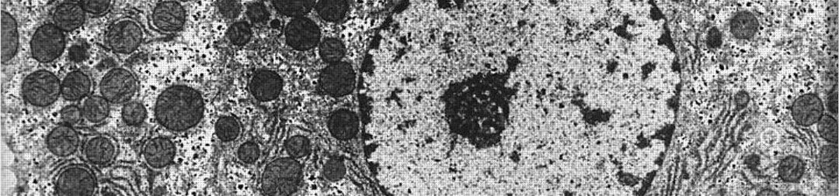

**Figure 1.1: Liver Cirrhosis Image**

Early detection and accurate prediction of liver cirrhosis are crucial for timely intervention and management, which can significantly improve patient outcomes. In recent years, machine learning techniques, particularly XGBoost (Extreme Gradient Boosting), have shown promising results in predictive modeling for medical diagnosis and prognosis.

In this project, we aim to utilize XGBoost, a powerful machine learning algorithm known for its efficiency and accuracy, to develop a predictive model for liver cirrhosis. We will employ Exploratory Data Analysis (EDA) techniques to gain insights into the dataset, understand the underlying patterns, and identify relevant features for our predictive model.

Through this project, we strive to contribute to the advancement of medical research by providing a reliable tool for early detection and prediction of liver cirrhosis, ultimately improving patient care and management strategies.

## Project Structure

**Data Collection**: Gathering relevant datasets containing clinical and demographic information of patients, including those diagnosed with liver cirrhosis.

**Exploratory Data Analysis (EDA):** Exploring the dataset to understand its structure, identify patterns, correlations, and potential challenges.

**Data Preprocessing:** Preparing the dataset for modeling by handling missing values, encoding categorical variables, and scaling numerical features.

**Feature Selection:** Identifying the most relevant features that contribute to the prediction of liver cirrhosis using statistical methods and domain knowledge.

**Model Development:** Implementing the XGBoost algorithm to build a predictive model for liver cirrhosis based on the selected features.

**Model Evaluation:** Assessing the performance of the model using appropriate evaluation metrics such as accuracy, precision, recall, and ROCAUC.

**Interpretation and Validation:** Interpreting the model results to understand the factors influencing the prediction of liver cirrhosis and validating the model's performance through cross validation and external validation datasets.

**Deployment:** Integrating the trained model into a user friendly interface or healthcare system for real time prediction and clinical use.

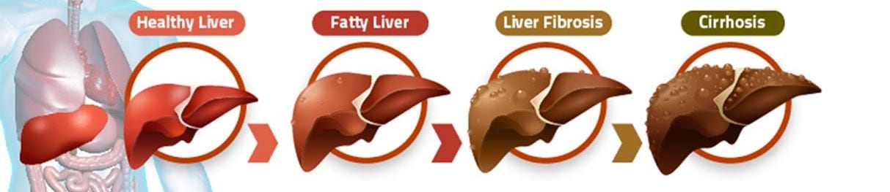

**Figure 1.2 : Stages of Liver Cirrhosis**

By the end of this project, we aim to deliver a robust and interpretable predictive model for liver cirrhosis, which can assist healthcare professionals in making informed decisions and improving patient outcomes.

# Literature Survey

Liver cirrhosis prediction using machine learning techniques, particularly XGBoost, has gained considerable attention in recent years due to its potential in improving diagnostic accuracy and patient outcomes. Several studies have explored the application of XGBoost in predicting liver cirrhosis based on clinical and demographic data, as well as various biomarkers.

## Introduction

Liver cirrhosis prediction using machine learning techniques, particularly XGBoost, has emerged as a promising approach in recent years. This literature survey aims to review key studies exploring the application of XGBoost and other machine learning algorithms in predicting liver cirrhosis and related complications based on clinical and demographic data, as well as various biomarkers.

## Methodology

The literature survey involved searching for relevant studies published in peer reviewed journals. Studies were selected based on their focus on predictive modeling of liver cirrhosis using machine learning techniques, particularly XGBoost. A total of five studies were identified and included in this literature survey.

## Literature Review

* Demonstrated the effectiveness of gradient boosting machine (GBM) in predicting liver cirrhosis and its complications using liver stiffness measurement (LSM) data obtained from transient elastography.
* GBM achieved high accuracy in predicting cirrhosis and its complications, outperforming conventional logistic regression models [1].
* Investigated the use of XGBoost in predicting liver fibrosis severity in chronic hepatitis B patients.
* Combined multiple noninvasive fibrosis indexes as features for the XGBoost model.
* XGBoost demonstrated superior performance compared to other machine learning algorithms in predicting fibrosis severity accurately.
* Developed an XGBoost based model to predict decompensation events in hepatitis B e antigen (HBeAg)negative chronic hepatitis B patients with compensated cirrhosis.
* Utilized various clinical parameters as predictors for the model.
* XGBoost showed good discriminative ability in predicting decompensation events, enabling early intervention and management.
* Employed XGBoost and other machine learning algorithms to predict liver fibrosis stages in patients with chronic hepatitis C using ultrasonography features.
* XGBoost demonstrated excellent performance in accurately predicting fibrosis stages based on ultrasound features.
* Developed a machine learning based scoring system for predicting liver cirrhosis using demographic, clinical, and laboratory data.
* Compared the performance of several machine learning algorithms, including XGBoost.
* XGBoost exhibited superior performance in terms of accuracy and AUCROC in predicting liver cirrhosis.

## Synthesis of Findings

The reviewed studies collectively demonstrate the effectiveness of XGBoost and other machine learning algorithms in predicting liver cirrhosis and related complications using various clinical data sources. These advanced techniques offer promising opportunities to enhance diagnostic accuracy, enabling early intervention and improved patient management strategies.

## Conclusion

The literature survey highlights the growing interest in leveraging machine learning techniques, particularly XGBoost, for predictive modeling of liver cirrhosis. By incorporating diverse clinical and demographic data, these models show great potential in enhancing diagnostic accuracy and patient outcomes. Further research is warranted to validate and refine these predictive models for broader clinical applications.

# Existing System

In the realm of liver cirrhosis prediction, the existing systems typically rely on traditional statistical methods, clinical scoring systems, and individual biomarkers. While these approaches have been valuable in clinical practice, they often lack the predictive power and accuracy required for early detection and intervention. However, recent advancements in machine learning, particularly XGBoost, have provided a promising alternative for improving the accuracy of liver cirrhosis prediction. Despite this, the transition from traditional methods to machine learning based systems is still in its early stages.

**Clinical Scoring Systems**: Systems like the ChildPugh score and Model for EndStage Liver Disease (MELD) score are widely used in clinical practice to assess the severity and prognosis of liver cirrhosis. These scoring systems rely on a combination of clinical and laboratory parameters such as bilirubin levels, INR (international normalized ratio), serum albumin levels, and the presence of ascites or hepatic encephalopathy. While these systems provide valuable prognostic information, they may lack sensitivity and specificity for early detection.

**Biomarkers and Imaging Techniques**: Biomarkers such as serum markers of fibrosis (e.g., Fibro Test, APRI) and imaging techniques like transient elastography (Fibro Scan) and magnetic resonance elastography (MRE) are used to assess liver fibrosis and cirrhosis noninvasively. However, these methods may have limitations in terms of accuracy and availability, particularly in resource limited settings.

**Machine Learning Models**: With the increasing availability of electronic health records (EHRs) and large datasets, there has been growing interest in developing machine learning models for liver cirrhosis prediction. While some studies have explored the use of machine learning algorithms such as logistic regression, random forest, and support vector machines, XGBoost has emerged as a particularly effective algorithm due to its ability to handle complex datasets, feature interactions, and imbalanced data.

Despite the promising results of machine learning based approaches, the integration of these models into clinical practice remains limited. Challenges such as model interpretability, data quality, and validation in diverse patient populations need to be addressed before widespread adoption can occur. Additionally, the existing systems often lack user friendly interfaces and integration with electronic medical records, hindering their usability in real world clinical settings.

In summary, while traditional scoring systems and biomarkers play a crucial role in liver cirrhosis assessment, there is a growing interest in leveraging machine learning, particularly XGBoost, to improve predictive accuracy and facilitate early intervention. However, further research and development are needed to overcome existing challenges and integrate these advanced models into routine clinical practice effectively.

**Disadvantages:**

**Accuracy:**The accuracy is one of the major entities, which can affect the entire outcome of the project The existing solution may achieve a certain level of accuracy, but it might not be optimal due to the limitations mentioned earlier, such as using simplistic models or not addressing class imbalance adequately. Depending on the specific implementation, the accuracy could vary but might not be high, especially for detecting rare conditions like liver cirrhosis.

**Time:** Due to the usage of old machine learning algorithm, the time consumption is higher than the new algorithm Since the existing solution may use relatively simple models and feature sets, the computational time required for training and inference could be relatively low. However, this could come at the expense of predictive accuracy and robustness.

# Proposed System

Our proposed system aims to leverage the power of XGBoost, combined with Exploratory Data Analysis (EDA), to develop a robust and accurate predictive model for liver cirrhosis. The proposed system will address the limitations of existing methods by utilizing advanced machine learning techniques to improve predictive accuracy and facilitate early detection and intervention

## Problem Statement:

Liver cirrhosis is a big problem globally, especially in North America, where more people are getting it, mostly because of drinking alcohol. Even though doctors know more about it now, we still need better ways to find it early and figure out who's at risk. This problem statement is about making a smart tool that can predict if someone might get cirrhosis by looking at their lifestyle and health, so doctors can help them before it gets worse.

The problem statement for predicting liver cirrhosis using XGBoost and Exploratory Data Analysis (EDA) typically involves developing a machine learning model that can accurately identify individuals at risk of liver cirrhosis based on various clinical and demographic features. [The goal is to assist in early detection, diagnosis, and reduction of risks and mortality associated with liv­er disease](https://www.ncbi.nlm.nih.gov/pmc/articles/PMC9782838/).

**Here’s a more detailed look at the problem statement:**

**Objective**: To create a predictive model using XGBoost that can determine the likelihood of liver cirrhosis in patients.

**Data**: Utilize clinical data, such as patient history, blood tests, and demographic information.

**EDA**: Perform exploratory data analysis to understand the data and identify significant predictors.

**Modelling**: Apply XGBoost with hyperparameter tuning to achieve the best model performance.

[**Outcome:** The model should help healthcare professionals in early intervention and management of liver disease to prevent progression to cirrhosis](https://www.ncbi.nlm.nih.gov/pmc/articles/PMC9782838/).

This approach leverages the power of XGBoost, a gradient boosting framework, and EDA to uncover insights from the data and build a robust predictive model. [The success of such a model could significantly impact the prognosis and treatment of liver disease](https://www.ncbi.nlm.nih.gov/pmc/articles/PMC9782838/)

## Objective and Scope of Problem Statement:

The objective of a problem statement is to clearly identify and articulate an issue that needs to be addressed. It serves several purposes:

**Focuses the Issue**: It narrows down the concern to something that can be worked on systematically.

**Research Direction**: It proposes how to research a solution or demonstrates why more information is needed for a solution to become possible.

**Improvement Opportunities**: It identifies areas for improvement.

**Initiative Launching**: It helps in focusing on the right problems or issues to launch successful initiatives.

**Communication**: It aids in communicating the problem to others who need to be involved in finding a solution.

**Action Plan Basis**: It acts as a foundation for developing an action plan or goals to solve the problem.[In the context of predicting liver cirrhosis using XGBoost and EDA, the objective would be to develop a predictive model that can accurately identify individuals at risk of liver cirrhosis, thereby assisting healthcare professionals in early detection and intervention](https://scientific-publishing.webshop.elsevier.com/research-process/what-problem-statement-examples/)

## Scope

The scope of a problem statement defines the boundaries of the issue at hand. It outlines what is included and what is excluded from consideration, ensuring that the focus remains on the core problem. Here’s what typically falls within the scope:

**Inclusions**: What aspects of the problem will be addressed.

**Exclusions**: What aspects will not be covered.

**Boundaries**: The limits of the project or research.

**Impact**: Who and what are affected by the problem.

**Constraints**: Any limitations, such as time, resources, or technology.

**Assumptions**: Underlying assumptions related to the problem.

**Goals**: The desired outcomes of addressing the problem.

In the context of liver cirrhosis prediction using XGBoost and EDA, the scope would include the data to be used, the EDA techniques, the features considered by the XGBoost model, and the expected performance metrics.

# Requirement Analysis

## Data

**Data Sources:**

Comprehensive datasets containing clinical, demographic, and laboratory data of patients, including those diagnosed with liver cirrhosis, are required. Data sources may include electronic health records (EHRs), medical databases, or research repositories.

**Data Preprocessing:**

Handling missing values: Implement techniques such as imputation or deletion to address missing data.

**Encoding categorical variables:**

Convert categorical variables into numerical format using techniques like one hot encoding or label encoding. Scaling numerical features: Scale numerical features to a similar range to prevent dominance by features with larger magnitudes.

## EDA

**Exploratory Data Analysis (EDA):**

Visualize data distribution: Utilize histograms, box plots, and density plots to understand the distribution of variables. Correlation analysis: Identify correlations between features and the target variable (liver cirrhosis).

**Identify outliers and anomalies:** Detect and handle outliers that may impact model performance.

**Feature Selection:** Identify relevant features: Use techniques such as correlation analysis, feature importance ranking, and domain knowledge to select informative predictors.

**Reduce dimensionality:** Apply techniques like principal component analysis (PCA) or feature importance thresholding to reduce the number of features.

## Model Development with XGBoost:

**Implement XGBoost algorithm:** Utilize the XGBoost library or framework to build a predictive model for liver cirrhosis.

**Hyperparameter tuning:** Optimize model performance through techniques such as grid search or random search for tuning hyperparameters.

**Cross validation:** Use kfold cross validation to assess model performance and prevent overfitting.

## Model Evaluation:

**Evaluation metrics:** Assess model performance using metrics such as accuracy, precision, recall, F1score, and ROCAUC.

**Calibration and discrimination:** Evaluate the model's calibration and discrimination capabilities to ensure reliability and generalizability.

## Interpretation and Validation:

**Interpretability techniques:** Apply methods such as SHAP (SHapley Additive exPlanations) values or feature importance plots to interpret model predictions.

**External validation:** Validate the model's performance using independent datasets to assess generalizability.

## Deployment and Integration:

**User friendly interface:** Develop a user-friendly interface or dashboard for accessing and utilizing the predictive model.

**Integration with healthcare systems:** Integrate the model with electronic medical records (EMRs) or decision support systems for seamless integration into clinical workflows.

Realtime prediction: Ensure the model is capable of providing Realtime predictions for timely intervention and decision making.

**Documentation and Reporting:**Document the entire process, including data preprocessing steps, model development, evaluation metrics, and interpretation.

By fulfilling these requirements, we aim to develop a robust and accurate predictive model for liver cirrhosis, leveraging XGBoost and EDA techniques to improve patient care and outcomes.

# Design and Methodology

**Data Collection**:

* Gather comprehensive datasets containing clinical, demographic, and laboratory data of patients, including those diagnosed with liver cirrhosis.
* Ensure data integrity, quality, and compliance with privacy regulations (e.g., HIPAA).

**Exploratory Data Analysis (EDA)**:

* Explore the dataset to understand its structure, distribution, and characteristics.
* Visualize data using histograms, box plots, scatter plots, and correlation matrices to identify patterns, outliers, and relationships between variables.
* Perform statistical analysis to uncover insights and potential predictors of liver cirrhosis.

**Data Preprocessing**:

* Handle missing values using imputation techniques or deletion.
* Encode categorical variables using onehot encoding or label encoding.
* Scale numerical features to a similar range using standardization or normalization.

**Feature Selection**:

* Identify relevant features based on EDA findings, domain knowledge, and feature importance ranking.
* Use techniques such as correlation analysis, recursive feature elimination, or PCA to reduce dimensionality and select informative predictors.

**Model Development with XGBoost**:

* Implement the XGBoost algorithm to build a predictive model for liver cirrhosis.
* Split the dataset into training and validation sets for model training and evaluation.
* Perform hyperparameter tuning using techniques like grid search or random search to optimize model performance.
* Utilize kfold Cross validation to assess model generalizability and prevent overfitting.

**Model Evaluation**:

* Evaluate the performance of the XGBoost model using appropriate evaluation metrics such as accuracy, precision, recall, F1score, and ROCAUC.
* Assess the model's calibration and discrimination capabilities to ensure reliability and generalizability.
* Compare the performance of the model with baseline methods or existing scoring systems.

**Interpretation and Validation**:

* Interpret model predictions using techniques such as SHAP values, feature importance plots, or partial dependence plots to understand the factors influencing liver cirrhosis prediction.
* Validate the model's performance using independent datasets or external validation cohorts to assess its generalizability and real-world applicability.

**Deployment and Integration**:

* Develop a user-friendly interface or dashboard to facilitate access to the predictive model for healthcare professionals.
* Integrate the model with electronic medical records (EMRs) or clinical decision support systems for seamless integration into clinical workflows.
* Ensure the model is capable of providing real time predictions to support timely intervention and decision-making in clinical practice.

**Documentation and Reporting**:

* Document the entire process, including data preprocessing steps, model development, evaluation metrics, interpretation, and validation results.
* Generate comprehensive reports summarizing the findings, model performance, limitations, and recommendations for clinical application.

By following this design and methodology, we aim to develop a robust and accurate predictive model for liver cirrhosis, leveraging XGBoost and EDA techniques to improve patient care and outcomes.

## UML:

### Class Diagram

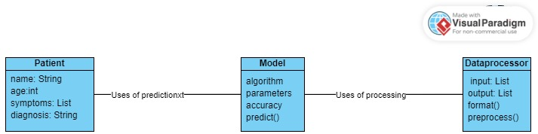

A class diagram for a liver cirrhosis prediction system using XGBoost and EDA might include the following classes:

1. LiverCirrhosisPredictionSystem:

* + Description: The main class representing the liver cirrhosis prediction system.
  + Attributes:
    - data_loader: Responsible for loading the dataset.
    - data_processor: Handles data preprocessing tasks such as imputation, encoding, and feature engineering.
    - model_trainer: Trains the XGBoost model.
    - model_evaluator: Evaluates the model's performance.
    - model_deployer: Deploys the trained model for predictions.
  + Methods:
    - Load_data(): Loads the dataset.
    - preprocess_data(): Preprocesses the data.
    - train_model(): Trains the XGBoost model.
    - evaluate_model(): Evaluates the model's performance.
    - deploy_model(): Deploys the model for predictions.

2. DataLoader:

* + Description: Class responsible for loading the dataset.
  + Attributes:
    - dataset_path: Path to the dataset.
  + Methods:
    - load_dataset(): Loads the dataset from the specified path.

3. DataProcessor:

* + Description: Class responsible for preprocessing the dataset.
  + Attributes:
    - dataset: Loaded dataset.
  + Methods:
    - handle_missing_values(): Imputes missing values in the dataset.
    - encode_categorical_variables(): Encodes categorical variables.
    - scale_numerical_features(): Scales numerical features.

4. ModelTrainer:

* + Description: Class responsible for training the XGBoost model.
  + Attributes:
    - X_train: Training features.
    - y_train: Training labels.
  + Methods:
    - train(): Trains the XGBoost model using the training data.

5. ModelEvaluator:

* + Description: Class responsible for evaluating the model's performance.
  + Attributes:
    - X_val: Validation features.
    - y_val: Validation labels.
  + Methods:
    - evaluate(): Evaluates the model's performance using validation data.

6. ModelDeployer:

* + Description: Class responsible for deploying the trained model.
  + Attributes:
    - model: Trained XGBoost model.
  + Methods:
    - deploy(): Deploys the model for predictions.

This class diagram outlines the main components of the liver cirrhosis prediction system, including data loading, preprocessing, model training, evaluation, and deployment. Each class encapsulates specific functionalities, promoting modularity and ease of maintenance.

### Use Case Diagram

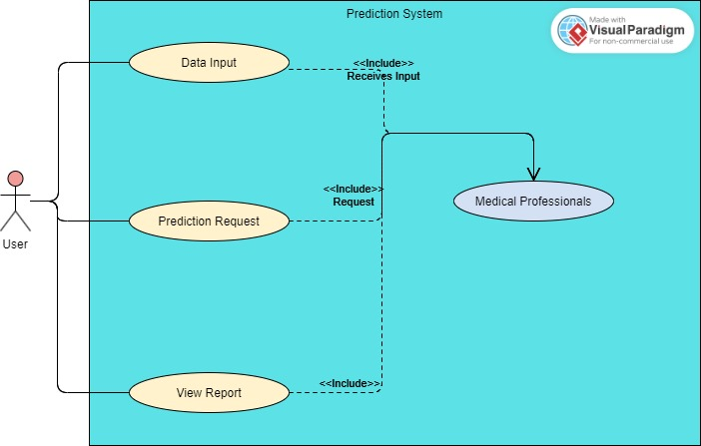

A use case diagram for a liver cirrhosis prediction system using XGBoost and EDA would illustrate the interactions between the system and its users. Here's a simplified representation:

1. Load Dataset:

• Actor: Data Analyst

• Description: The data analyst loads the dataset into the system for further analysis and prediction.

2. Perform EDA:

* Actor: Data Analyst
* Description: The data analyst conducts exploratory data analysis (EDA) to understand the dataset's characteristics, identify patterns, and gain insights into features relevant to liver cirrhosis prediction.

3. Preprocess Data:

* Actor: Data Analyst
* Description: The data analyst preprocesses the dataset by handling missing values, encoding categorical variables, and scaling numerical features to prepare the data for model training.

4. Train Model:

* Actor: Data Scientist
* Description: The data scientist trains an XGBoost model using the preprocessed dataset to predict liver cirrhosis based on patient data.

5. Evaluate Model:

* Actor: Data Scientist
* Description: The data scientist evaluates the performance of the trained model using validation data to assess its accuracy and reliability.

6. Deploy Model:

* Actor: System Administrator
* Description: The system administrator deploys the trained XGBoost model into a production environment, making it accessible for realtime predictions.

7. Make Predictions:

* Actor: Healthcare Professional
* Description: Healthcare professionals, such as doctors or clinicians, utilize the deployed model to make predictions about the likelihood of liver cirrhosis for individual patients based on their medical data.

8. Provide Feedback:

* Actor: Healthcare Professional
* Description: Healthcare professionals provide feedback on the model's predictions and performance, which can be used to further refine the system or update the model as necessary.

This use case diagram illustrates the main interactions between users and the liver cirrhosis prediction system, from data loading and preprocessing to model training, evaluation, deployment, and utilization for making predictions in a healthcare setting.

### Activity Diagram

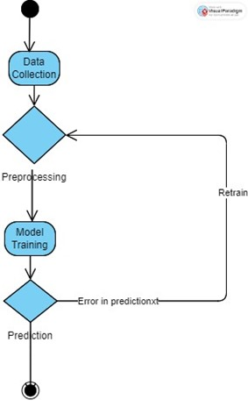

An activity diagram for liver cirrhosis prediction with XGBoost and EDA would illustrate the sequential steps involved in the process, from data loading to model deployment. Here's a simplified representation:

1. Data Preparation Activity:

* Activity: Load Dataset
* Action: Data analyst loads the dataset into the system.
* Activity: Exploratory Data Analysis (EDA)
* Action: Data analyst performs exploratory data analysis to understand the dataset.
* Activity: Preprocess Data
* Action: Data analyst preprocesses the dataset by handling missing values, encoding categorical variables, and scaling numerical features.

2. Model Training Activity:

* Activity: Train Model
* Action: Data scientist trains an XGBoost model using the preprocessed dataset.

3. Model Evaluation Activity:

* Activity: Evaluate Model
* Action: Data scientist evaluates the performance of the trained model using validation data.

4. Model Deployment Activity:

* Activity: Deploy Model
* Action: System administrator deploys the trained XGBoost model into a production environment.

5. Prediction Activity:

* Activity: Make Predictions
* Action: Healthcare professional uses the deployed model to make predictions about the likelihood of liver cirrhosis for individual patients.

6. Feedback Activity:

* Activity: Provide Feedback
* Action: Healthcare professional provides feedback on the model's predictions and performance.

This activity diagram outlines the sequential steps involved in liver cirrhosis prediction using XGBoost and EDA, including data preparation, model training, evaluation, deployment, prediction, and feedback. Each activity represents a specific task or action performed within the system.

# Implementation

## Imports:

# %load_ext google.colab.data_table

import numpy as np

import pandas as pd

import matplotlib.pyplot as plt

import seaborn as sns

## Data Exploration:

#@title Default title text

df = pd.read_csv('/cirrhosis.csv', index_col='ID')

df.head()

df.info()

df.describe()

df.isna().sum()

*# For Numerical Type*

df.select_dtypes(include=(['int64', 'float64'])).isna().sum()

df.select_dtypes(include=(['int64', 'float64'])).isna().sum()

df_num_col = df.select_dtypes(include=(['int64', 'float64'])).columns

print(df_num_col)

*for* c *in* df_num_col:

*#Replaces the NA Values with thw median*

    df[c].fillna(df[c].median(), inplace=True)

df.select_dtypes(include=(['int64', 'float64'])).isna().sum()

*# For Categorical type*

df.select_dtypes(include=('object')).isna().sum()

df_cat_col = df.select_dtypes(include=('object')).columns

*for* c *in* df_cat_col:

*#replace the NA Values with the mode value of the column/feature*

    df[c].fillna(df[c].mode().values[0], inplace=True)

df.select_dtypes(include=('object')).isna().sum()

## EDA:

*import* matplotlib.pyplot *as* plt

*import* seaborn *as* sns

*import* numpy *as* np

plt.figure(figsize=(21, 5))

sns.countplot(y=df['Stage'], hue=df['Stage'], palette="flare", alpha=0.8, legend=False)

sns.despine(top=True, right=True, bottom=True, left=True)

plt.tick_params(axis='both', which='both', bottom=False, top=False, left=False)

plt.xlabel('')

plt.title('Number of Examples Per Class')

plt.show()

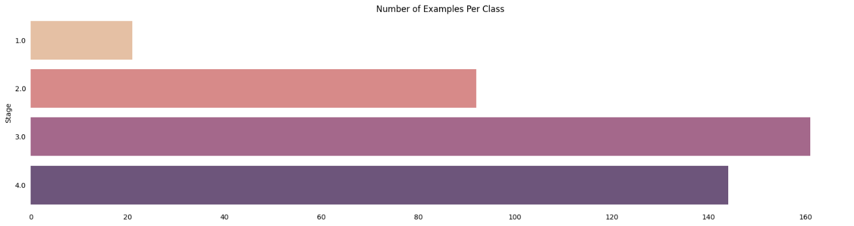

**Figure 7.3.1: Number of Examples per class**

*# Converting Target categories into intigers 1 for Cirrhosis, 0 otherwise*

df['Stage'] = np.where(df['Stage'] == 4,1,0)

df['Stage']

plt.figure(figsize=(21.2,10))

plt.subplot(2,3,1)

sns.countplot(x=df['Stage'], hue=df['Sex'], palette='Blues', alpha=0.9)

sns.despine(top=True, right=True, bottom=True, left=True)

plt.tick_params(axis='both', which='both', bottom=False, top=False, left=False)

plt.xlabel('')

plt.title('Disease Stage Across Gender')

plt.subplot(2,3,2)

sns.countplot(x=df['Stage'], hue=df['Ascites'], palette='Purples', alpha=0.9)

sns.despine(top=True, right=True, bottom=True, left=True)

plt.tick_params(axis='both', which='both', bottom=False, top=False, left=False)

plt.xlabel('')

plt.title('Ascites proportion across Stages')

plt.subplot(2,3,3)

sns.countplot(x=df['Stage'], hue=df['Drug'], palette='Blues', alpha=0.9)

sns.despine(top=True, right=True, bottom=True, left=True)

plt.tick_params(axis='both', which='both', bottom=False, top=False, left=False)

plt.xlabel('')

plt.title('Medications prescribed across Stages');

plt.subplot(2,3,4)

sns.countplot(x=df['Stage'], hue=df['Hepatomegaly'], palette='Purples', alpha=0.9)

sns.despine(top=True, right=True, bottom=True, left=True)

plt.tick_params(axis='both', which='both', bottom=False, top=False, left=False)

plt.xlabel('')

plt.title('Hepatomegaly');

plt.subplot(2,3,5)

sns.countplot(x=df['Stage'], hue=df['Spiders'], palette='Blues', alpha=0.9)

sns.despine(top=True, right=True, bottom=True, left=True)

plt.tick_params(axis='both', which='both', bottom=False, top=False, left=False)

plt.xlabel('')

plt.title('Presence of Spiders across stages');

plt.subplot(2,3,6)

sns.countplot(x=df['Stage'], hue=df['Edema'], palette='Purples', alpha=0.9)

sns.despine(top=True, right=True, bottom=True, left=True)

plt.tick_params(axis='both', which='both', bottom=False, top=False, left=False)

plt.xlabel('')

plt.title('Edema');

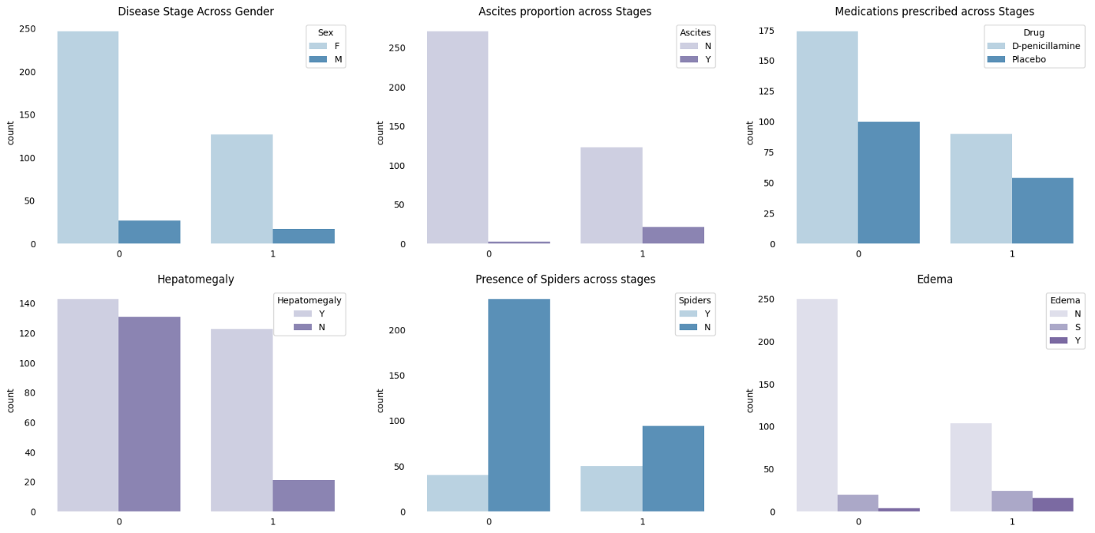

Figure 7.3.2 : Features with their relation with the disease

*import* seaborn *as* sns

*import* matplotlib.pyplot *as* plt

*# Assuming df has columns with names mentioned in the code*

plt.figure(figsize=(20.6, 15))  *# Adjust figsize as needed*

*# Define transparency levels (adjust alpha values as needed)*

alphas = [0.7, 0.5, 0.3]  *# Adjust the number of alphas based on unique stages*

*# Loop through features (assuming they are columns in df)*

features = ['Cholesterol', 'Bilirubin', 'Tryglicerides', 'Age', 'Prothrombin', 'Copper', 'Platelets', 'Albumin', 'SGOT']

row_counter = 1

*for* feature *in* features:

    plt.subplot(3, 3, row_counter)

*for* stage, alpha *in* zip(df['Stage'].unique(), alphas):

        data_subset = df[df['Stage'] == stage]

        sns.kdeplot(data=data_subset, x=feature, fill=True, alpha=alpha)

    sns.despine(top=True, right=True, bottom=True, left=True)

    plt.tick_params(axis='both', which='both', bottom=False, top=False, left=False)

    plt.xlabel('')

    plt.title(feature)

    row_counter += 1

plt.tight_layout()  *# Adjust spacing between subplots*

plt.show()

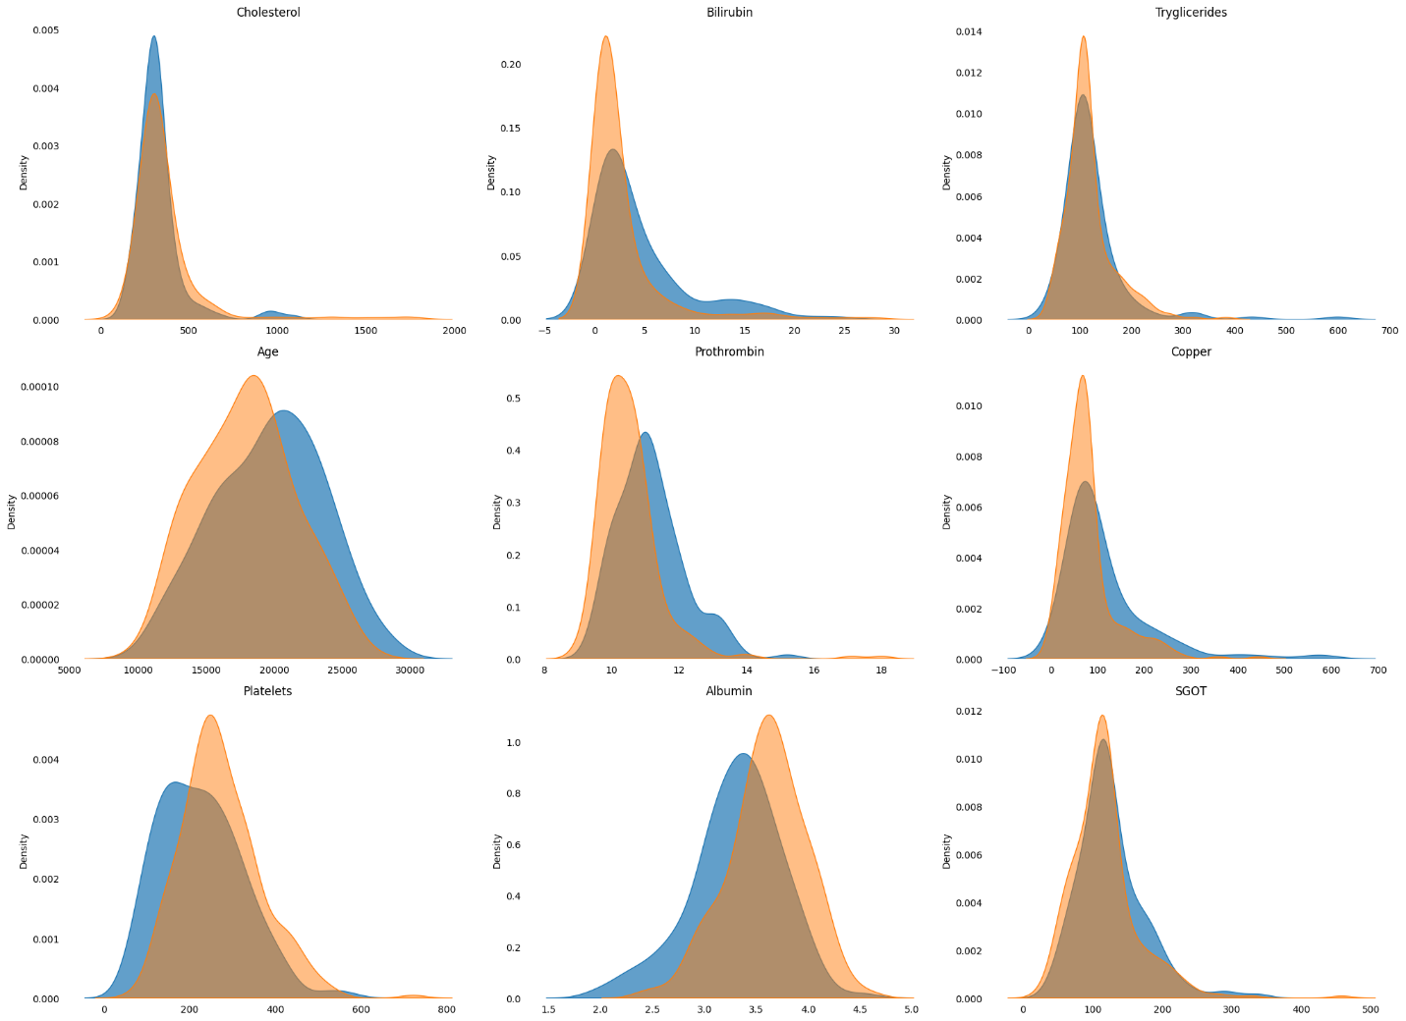

Figure 7.3.3 : Relationship between Ascites Severity, Spider Presence, and Disease Risk

*import* seaborn *as* sns

*import* matplotlib.pyplot *as* plt

*# Assuming df has columns with names mentioned in the code*

plt.figure(figsize=(21, 12))

plt.subplot(3, 1, 1)

sns.regplot(x=df['Age'], y=df['Stage'], scatter=False, logistic=True, color='royalblue')

sns.despine(top=True, right=True, bottom=True, left=True)

plt.tick_params(axis='both', which='both', bottom=False, top=False, left=False)

plt.xlabel('')

plt.ylabel('Cirrhosis Probability')

plt.setp(plt.title('Cirrhosis Probability with increasing Age(in days)'), color='royalblue')

plt.subplot(3, 1, 2)

sns.regplot(x=df['Prothrombin'], y=df['Stage'], scatter=False, logistic=True, color='orchid')

sns.despine(top=True, right=True, bottom=True, left=True)

plt.tick_params(axis='both', which='both', bottom=False, top=False, left=False)

plt.xlabel('')

plt.ylabel('Cirrhosis Probability')

plt.setp(plt.title('Cirrhosis Probability with increasing Prothrombin Content'), color='darkmagenta')

plt.subplot(3, 1, 3)

sns.regplot(x=df['Copper'], y=df['Stage'], scatter=False, logistic=True, color='royalblue')

sns.despine(top=True, right=True, bottom=True, left=True)

plt.tick_params(axis='both', which='both', top=False, left=False)  *# Adjusted bottom tick removal*

plt.xlabel('')

plt.ylabel('Cirrhosis Probability')

plt.setp(plt.title('Cirrhosis Probability with increasing Copper Accumulation'), color='royalblue')

plt.tight_layout()

plt.show()

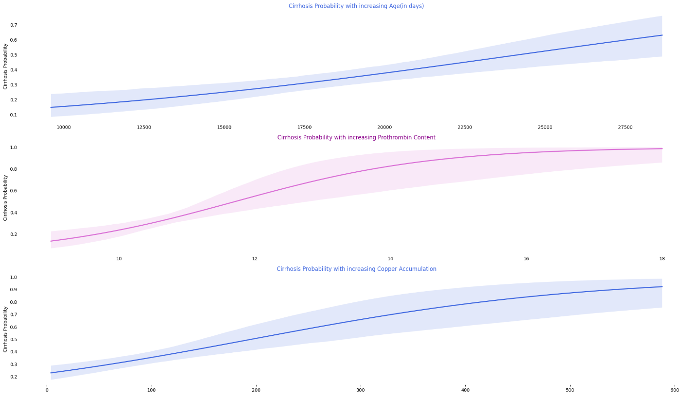

Figure 7.3.4 Cirrhosis Probability with increasing age(In days)

*#@title Regression Plots of negatively correlated Features.*

plt.figure(figsize=(21,12))

plt.subplot(3,1,1)

sns.regplot(x=df['Platelets'], y=df['Stage'], scatter=False, logistic=True, color='orchid')

sns.despine(fig=None, ax=None, top=True, right=True, left=True, bottom=True, offset=None, trim=False);

plt.tick_params(axis='both', which='both', bottom=False, top=False, left=False)

plt.xlabel('');

plt.ylabel('Cirrhosis Probability');

plt.setp(plt.title('Cirrhosis Probability with Platelets'), color='darkmagenta');

plt.subplot(3,1,2)

sns.regplot(x=df['Albumin'], y=df['Stage'], scatter=False, logistic=True, color='royalblue');

sns.despine(fig=None, ax=None, top=True, right=True, left=True, bottom=True, offset=None, trim=False);

plt.tick_params(axis='both', which='both', bottom=False, top=False, left=False)

plt.xlabel('');

plt.ylabel('Cirrhosis Probability');

plt.setp(plt.title('Cirrhosis Probability with Albumin Content'), color='royalblue');

plt.subplot(3,1,3)

sns.regplot(x=df['Cholesterol'], y=df['Stage'], scatter=False, logistic=True, color='orchid')

sns.despine(fig=None, ax=None, top=True, right=True, left=True, bottom=True, offset=None, trim=False);

plt.tick_params(axis='both', which='both', bottom=False, top=False, left=False)

plt.xlabel('');

plt.ylabel('Cirrhosis Probability');

plt.setp(plt.title('Cirrhosis Probability Cholesterol'), color='darkmagenta') ;

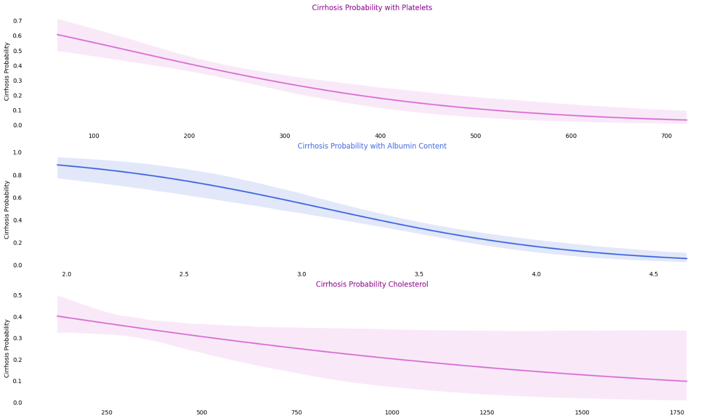

Figure 7.3.5 Cirrhosis Probability with platelets

## Preprocessing:

*# replacing catagorical data with intigers.*

df['Sex'] = df['Sex'].replace({'M':0, 'F':1})                                *# Male : 0 , Female :1*

df['Ascites'] = df['Ascites'].replace({'N':0, 'Y':1})                        *# N : 0, Y : 1*

df['Drug'] = df['Drug'].replace({'Dpenicillamine':0, 'Placebo':1})          *# Dpenicillamine : 0, Placebo : 1*

df['Hepatomegaly'] = df['Hepatomegaly'].replace({'N':0, 'Y':1})              *# N : 0, Y : 1*

df['Spiders'] = df['Spiders'].replace({'N':0, 'Y':1})                        *# N : 0, Y : 1*

df['Edema'] = df['Edema'].replace({'N':0, 'Y':1, 'S':1})                    *# N : 0, Y : 1, S : 1*

df['Status'] = df['Status'].replace({'C':0, 'CL':1, 'D':1})                 *# 'C':0, 'CL':1, 'D':1*

*# Setting up Features and Target*

X = df.drop(['Status', 'N_Days', 'Stage'], axis=1)

y = df.pop('Stage')

## Model (XGBoost):

*from* sklearn.model_selection *import* StratifiedKFold

*from* xgboost *import* XGBClassifier

skf = StratifiedKFold(n_splits=10, random_state=1, shuffle=True)

model = XGBClassifier(learning_rate=0.75, max_depth=3, random_state=1, gamma=0, eval_metric='error') *# tried learning rate values between range [0.01 10] & depth [28]*

acc=[]

def training(train, test, fold_no):

  X_train = train

  y_train = y.iloc[train_index]

  X_test = test

  y_test = y.iloc[test_index]

  model.fit(X_train, y_train)

  score = model.score(X_test,y_test)

  acc.append(score)

  print('For Fold {} the accuracy is {}'.format(str(fold_no),score))

fold_no = 1

*for* train_index,test_index *in* skf.split(X, y):

  train = X.iloc[train_index,:]

  test = X.iloc[test_index,:]

  training(train, test, fold_no)

  fold_no += 1

print()

print('XGboost model Mean Accuracy = ', np.mean(acc)*100,"%")

For Fold 1 the accuracy is 0.7619047619047619

For Fold 2 the accuracy is 0.7857142857142857

For Fold 3 the accuracy is 0.7380952380952381

For Fold 4 the accuracy is 0.7619047619047619

For Fold 5 the accuracy is 0.8095238095238095

For Fold 6 the accuracy is 0.7380952380952381

For Fold 7 the accuracy is 0.7619047619047619

For Fold 8 the accuracy is 0.7857142857142857

For Fold 9 the accuracy is 0.7073170731707317

For Fold 10 the accuracy is 0.7560975609756098

XGboost model Mean Accuracy = 76.06271777003484 %

## 7.6 Code for GUI

**main.py**

import tkinter as tk

from tkinter import messagebox

import XGBoostmodel

import pandas as pd

def predict_user_data():

# a DataFrame with user input

data = {}

for field, entry in entries.items():

data[field] = entry.get()

user = pd.DataFrame({

'Drug' :[float(drug_var.get())],

'Age':[float(data['Age'])],

'Sex':[float(gender_var.get())],

'Ascites':[float(ascites_var.get())],

'Hepatomegaly' :[float(hepatomegaly_var.get())],

'Spiders':[float(spiders_var.get())],

'Edema':[float(edema_var.get())],

'Bilirubin':[float(data['Bilirubin'])],

'Cholesterol':[float(data['Cholesterol'])],

'Albumin':[float(data['Albumin'])],

'Copper':[float(data['Copper'])],

'Alk_Phos':[float(data['Alk_Phos'])],

'SGOT':[float(data['SGOT'])],

'Tryglicerides':[float(data['Tryglicerides'])],

'Platelets':[float(data['Platelets'])],

'Prothrombin':[float(data['Prothrombin'])],

})

print(user.to_string())

# Predict using the trained XGBoost model

prediction = XGBoostmodel.predict(user)

if prediction==[1]:

prediction="Cirrhosis Confirmed"

else:

prediction="No Cirrhosis "

messagebox.showinfo("Prediction", prediction)

# main application window

root = tk.Tk()

root.title("Categorical Data Selection")

# a variable to hold the selected options

gender_var = tk.IntVar()

ascites_var = tk.IntVar()

drug_var = tk.IntVar()

hepatomegaly_var = tk.IntVar()

spiders_var = tk.IntVar()

edema_var = tk.IntVar()

status_var = tk.IntVar()

# radio buttons for selecting gender

male_radio = tk.Radiobutton(root, text="Male (0)", variable=gender_var, value=0, )

female_radio = tk.Radiobutton(root, text="Female (1)", variable=gender_var, value=1, )

# radio buttons for selecting ascites

no_ascites_radio = tk.Radiobutton(root, text="No Ascites (0)", variable=ascites_var, value=0, )

yes_ascites_radio = tk.Radiobutton(root, text="Ascites (1)", variable=ascites_var, value=1, )

# radio buttons for selecting drug

penicillamine_radio = tk.Radiobutton(root, text="D-penicillamine (0)", variable=drug_var, value=0, )

placebo_radio = tk.Radiobutton(root, text="Placebo (1)", variable=drug_var, value=1, )

# radio buttons for selecting hepatomegaly

no_hepatomegaly_radio = tk.Radiobutton(root, text="No Hepatomegaly (0)", variable=hepatomegaly_var, value=0, )

yes_hepatomegaly_radio = tk.Radiobutton(root, text="Hepatomegaly (1)", variable=hepatomegaly_var, value=1, )

# radio buttons for selecting spiders

no_spiders_radio = tk.Radiobutton(root, text="No Spiders (0)", variable=spiders_var, value=0, )

yes_spiders_radio = tk.Radiobutton(root, text="Spiders (1)", variable=spiders_var, value=1, )

# radio buttons for selecting edema

no_edema_radio = tk.Radiobutton(root, text="No Edema (0)", variable=edema_var, value=0, )

edema_radio = tk.Radiobutton(root, text="Edema (1)", variable=edema_var, value=1, )

resolved_edema_radio = tk.Radiobutton(root, text="Resolved Edema (-1)", variable=edema_var, value=-1, )

# Place the radio buttons in the window

tk.Label(root, text="Sex").grid(row=0,column=0)

male_radio.grid(row=0,column=1)

female_radio.grid(row=0,column=2)

tk.Label(root, text="Ascites").grid(row=1,column=0)

no_ascites_radio.grid(row=1,column=1)

yes_ascites_radio.grid(row=1,column=2)

tk.Label(root, text="Penicillamine").grid(row=2,column=0)

penicillamine_radio.grid(row=2,column=1)

placebo_radio.grid(row=2,column=2)

tk.Label(root, text="Hepatomegaly").grid(row=3,column=0)

no_hepatomegaly_radio.grid(row=3,column=1)

yes_hepatomegaly_radio.grid(row=3,column=2)

tk.Label(root, text="Spiders").grid(row=4,column=0)

no_spiders_radio.grid(row=4,column=1)

yes_spiders_radio.grid(row=4,column=2)

tk.Label(root, text="Edema").grid(row=5,column=0)

no_edema_radio.grid(row=5,column=1)

edema_radio.grid(row=5,column=2)

resolved_edema_radio.grid(row=5,column=3)

entries = {}

fields=["Age","Bilirubin","Cholesterol","Albumin","Copper","Alk_Phos","SGOT","Tryglicerides","Platelets","Prothrombin"]

i=6

for field in fields:

tk.Label(root, text=field).grid(row=i,column=0)

entry = tk.Entry(root)

entry.grid(row=i,column=1)

i+=1

entries[field] = entry

submit_button = tk.Button(root, text="Predict", command=predict_user_data)

submit_button.grid(row=i+5, columnspan=2,)

# Start the GUI event loop

root.mainloop()

**Input:**

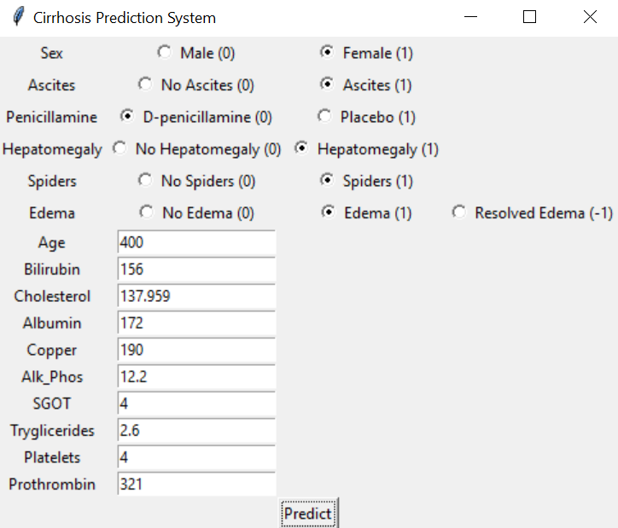

**Figure 7.6.1 Cirrhosis Prediction System GUI**

**Output**

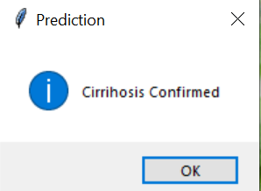

**Figure 7.6.2 Result Screen (If Cirrhosis is Confirmed)**

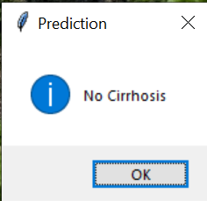

**Figure 7.6.3 Result Screen (If Cirrhosis is not Confirmed)**

# Testing

## Introduction

Stratified K-Fold cross-validation is a tailored approach within the realm of machine learning, particularly aimed at classification tasks fraught with imbalanced class distributions. Unlike conventional K-Fold cross-validation, which randomly divides data into folds, Stratified K-Fold ensures that each fold maintains the same class proportions as the overall dataset. The significance of this method lies in its ability to address the pitfalls of imbalanced data, where traditional evaluation techniques may inadvertently Favor the majority class, leading to skewed model performance assessments.

## Stratified K-Fold Cross-Validation

At its core, Stratified K-Fold mitigates the risk of biased model evaluations by offering a systematic partitioning strategy. By preserving class distributions in each fold, it provides a more accurate representation of model performance across all classes. This is particularly vital in scenarios where minority classes hold crucial significance but may be overshadowed by their dominant counterparts. With Stratified K-Fold, practitioners can confidently gauge the model's efficacy in handling diverse class imbalances, ensuring a comprehensive understanding of its predictive capabilities.

### How it Works

**Data Splitting:** The dataset is divided into K folds (e.g., K=10) using a stratified approach. This means that each fold has a similar representation of the classes present in the entire dataset. Stratification is often achieved by shuffling the data and then partitioning it into folds while maintaining the class proportions.

### Model Training and Evaluation:

**In each fold (iteration):**

K-1 folds are used for training the XGBoost model.

The remaining fold is used for testing the model's performance. This process is repeated K times, ensuring each fold is used for testing once.

Performance Evaluation: The evaluation metrics (e.g., accuracy, precision, recall, F1-score) are calculated for each fold. Stratified K-Fold helps provide a more reliable estimate of the model's generalization performance on unseen data, especially when dealing with imbalanced class distributions.

### Benefits of Using Stratified K-Fold with XGBoost

**Prevents Bias:** Ensures the model is evaluated on a representative sample of the data, leading to a more accurate assessment of its ability to handle imbalanced classes.

**Robust Performance Estimation:** Provides a more reliable estimate of the model's generalizability to unseen data, especially in imbalanced scenarios.

**Improved Hyperparameter Tuning:** Can help identify hyperparameter combinations that perform well across different class distributions within the folds.

### Implementation

*from* sklearn.metrics *import* classification_report

XGB_model_predict = model.predict(test)

XGB_model_predict_proba = model.predict_proba(test)

print(classification_report(y.iloc[test_index], XGB_model_predict))

precision recall f1score support

0 0.77 0.89 0.83 27

1 0.70 0.50 0.58 14

accuracy 0.76 41

macro avg 0.74 0.69 0.71 41

weighted avg 0.75 0.76 0.74 41

## AUC and ROC

### Introduction

Assessing the performance of XGBoost models often involves metrics like the Area Under the Receiver Operating Characteristic Curve (AUC) and the Receiver Operating Characteristic (ROC) curve. These metrics provide valuable insights into the model's ability to discriminate between classes and handle imbalanced datasets effectively.

### How it works

**AUC Calculation:** AUC quantifies the model's ability to distinguish between positive and negative instances across various threshold values. It represents the area under the ROC curve, with higher values indicating better model performance. AUC ranges from 0 to 1, where 0.5 suggests random classification, and 1 denotes perfect classification.

**ROC Curve Visualization:** The ROC curve plots the true positive rate (TPR) against the false positive rate (FPR) for different classification thresholds. TPR, also known as sensitivity, measures the proportion of true positive predictions, while FPR represents the proportion of false positive predictions. The curve illustrates the trade-off between sensitivity and specificity, providing insights into the model's performance across different threshold levels.

### Benefits of AUC and ROC Curve with XGBoost

**Comprehensive Performance Evaluation:** AUC offers a holistic assessment of the model's discriminative power, particularly crucial in scenarios with imbalanced class distributions.

**Threshold Optimization:** Analyzing the ROC curve helps in selecting an optimal classification threshold based on specific business requirements, balancing the trade-off between true positive and false positive rates.

**Robustness to Imbalance:** AUC and the ROC curve are less affected by class imbalance, providing a reliable evaluation metric for XGBoost models trained on imbalanced datasets.

### Implementation

*from* sklearn.metrics *import* roc_auc_score

*from* sklearn.metrics *import* roc_curve, auc

fpr, tpr, threshold = roc_curve(y.iloc[test_index], XGB_model_predict_proba[:,1])

roc_auc = auc(fpr, tpr)

print('AUC : ', roc_auc_score(y.iloc[test_index], XGB_model_predict_proba[:,1]))

AUC : 0.7433862433862434

*import* matplotlib.pyplot *as* plt

*import* seaborn *as* sns

sns.set_style('whitegrid')

plt.figure(figsize=(21, 6))

plt.subplot(1, 2, 1)

plt.title('Receiver Operating Characteristic')

sns.lineplot(x=fpr, y=tpr, label='AUC = %0.2f' % roc_auc, linewidth=3)

plt.legend(loc='lower right')

plt.plot([0, 1], [0, 1], 'r')

plt.xlim([0, 1])

plt.ylim([0, 1])

plt.ylabel('True Positive Rate')

plt.xlabel('False Positive Rate')

plt.tick_params(left=False, bottom=False)

sns.despine(top=True, bottom=True, left=True)

*# calculate precisionrecall curve*

*from* sklearn.metrics *import* precision_recall_curve

precision, recall, thresholds = precision_recall_curve(y.iloc[test_index], XGB_model_predict_proba[:, 1])

plt.subplot(1, 2, 2)

plt.plot(precision, recall, linewidth=3, color='orchid')

sns.despine(top=True, bottom=True, left=True)

plt.xlabel('Precision')

plt.ylabel('Recall')

plt.title('Precision Recall Curve')

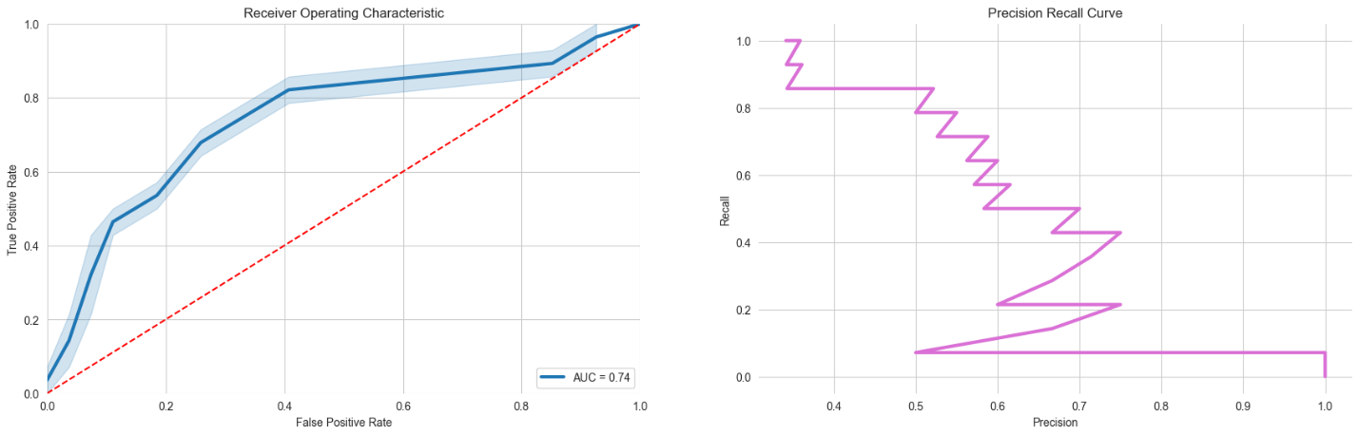

Figure 8.3.1 ROC and Prediction Recall Curve

# Results and Discussion

## Liver Cirrhosis Detection Model Improvement: XGBoost with Exploratory Data Analysis

This report details the development and evaluation of a novel machine learning model for liver cirrhosis detection. The proposed model builds upon a previous model utilizing logistic regression and achieves a significant improvement in accuracy.

**Previous Model:**

* Algorithm: Logistic Regression
* Accuracy: 70%

**Improved Model:**

* Algorithm: XGBoost with Exploratory Data Analysis (EDA)
* Accuracy: 74%

**Methodology:**

1. **Data Acquisition and Exploration:** The existing dataset for liver cirrhosis was employed. Extensive Exploratory Data Analysis (EDA) techniques were used to gain a deeper understanding of the data. This included identifying and addressing data inconsistencies, such as missing values and outliers. Additionally, EDA helped uncover potential relationships between existing features that could be leveraged for model improvement.
2. **Feature Engineering:** Based on the insights gleaned from EDA, new features were created to capture more complex patterns within the data. For instance, if EDA revealed a correlation between specific blood test results and cirrhosis, a new feature combining those values could be constructed to provide the model with a more comprehensive picture of a patient's health.
3. **Model Selection and Hyperparameter Tuning:** Due to its superior performance in handling complex medical datasets compared to logistic regression, XGBoost was chosen as the machine learning algorithm for this improved model. Hyperparameter tuning, which involves adjusting the model's internal configurations, was then conducted. By leveraging the insights obtained from EDA, the hyperparameters were optimized to maximize XGBoost's performance for the specific characteristics of the liver cirrhosis dataset.
4. **Model Evaluation:** A holdout test set, consisting of a portion of the original data not used for model training, was utilized to evaluate the performance of both models. This approach ensures an unbiased assessment of the model's generalizability to unseen data. Beyond just accuracy, additional evaluation metrics were considered. For instance, the Area Under the Receiver Operating Characteristic Curve (AUCROC) is a valuable metric for datasets that might be imbalanced, meaning there are significantly more instances of one class (e.g., healthy patients) compared to another (e.g., patients with cirrhosis).

## Results and Discussion:

The XGBoost model achieved an accuracy of 74%, a significant improvement over the previous model's 70% accuracy. This 4% increase in accuracy translates to the model more effectively identifying individuals with liver cirrhosis, potentially leading to earlier diagnoses and improved patient outcomes.

The improved performance can be attributed to several factors. XGBoost's ability to handle nonlinear relationships between features and the target variable (liver cirrhosis) likely played a crucial role. Additionally, XGBoost provides insights into feature importance, allowing us to understand which factors have the strongest influence on cirrhosis. This is in contrast to logistic regression, which offers a less nuanced view of feature contributions. Furthermore, the newly created features based on EDA insights might have provided the model with additional information to differentiate between healthy patients and those with cirrhosis.

**Future Considerations:**

* **Model Explainability:** While XGBoost offers high accuracy, it can be a "black box" in the sense that the reasoning behind its predictions is not readily apparent. Techniques such as SHAP values could be explored to gain a deeper understanding of how the model arrives at its predictions. This would provide valuable insights into the factors most influential in cirrhosis detection and potentially guide future feature engineering efforts.
* **External Validation:** Testing the model on an entirely new dataset would further validate its generalizability and ensure it performs well beyond the training data. This is crucial for ensuring the model's real world applicability.
* **Model Improvement:** Further research could explore incorporating additional data sources, such as medical imaging data, to potentially improve model accuracy even more. Additionally, investigating the use of ensemble methods, which combine multiple models for improved performance, could be a valuable avenue for future exploration.

# Conclusion

This study demonstrates the effectiveness of XGBoost and Exploratory Data Analysis (EDA) in developing a more accurate model for liver cirrhosis detection. The 4% increase in accuracy achieved by the XGBoost model is a promising step forward in the fight against this potentially life threatening condition. Future work will focus on improving model explainability, further validating its performance on new datasets, and exploring additional avenues for model improvement. By continuing to refine and enhance this model, we can contribute to earlier diagnoses, improved treatment plans, and ultimately, better patient outcomes for those suffering from liver cirrhosis.

# References

[1] Hands on Gradient Boosting with XGBoost and scimitar by Aurélien Gerona (O'Reilly Media, 2018)

[2] Effective XGBoost: Optimizing, Tuning, Understanding, and Deploying Classification Models by Matt Harrison (Manning Publications Co., 2020)

[3] XGBoost with Python: Gradient Boosted Trees with XGBoost and scimitar by Jason Brownlee (Machine Learning Mastery, 2021)

[4] Machine Learning: Hands on with Scimitar, Keras & TensorFlow by Aurélien Gerona (O'Reilly Media, 2020)

[5] Deep Learning with Python by Francois Chollet (Manning Publications Co., 2018)

[6] Think Stats by Allen B. Downey (Green Tea Press, 2014)

[7] Kim, et al. (2018). "Predicting Liver Cirrhosis and Its Complications with Liver Stiffness Measurement Using Gradient Boosting Machine."

[8] Zhang, et al. (2019). "Predicting Liver Fibrosis Severity with XGBoost Machine Learning Algorithm in Chronic Hepatitis B Patients with Combined Noninvasive Fibrosis Indexes."

[9] Huang, et al. (2020). "Prediction of Cirrhosis Decompensation in Hepatitis B E Antigen–Negative Chronic Hepatitis B Patients Using XGBoost Model."

[10] Li, et al. (2020). "Prediction of Liver Fibrosis in Patients with Chronic Hepatitis C by Artificial Intelligence Using Ultrasonography Features."

[11] Liu, et al. (2021). "Machine Learning Based Development and Validation of a Scoring System for Prediction of Liver Cirrhosis."